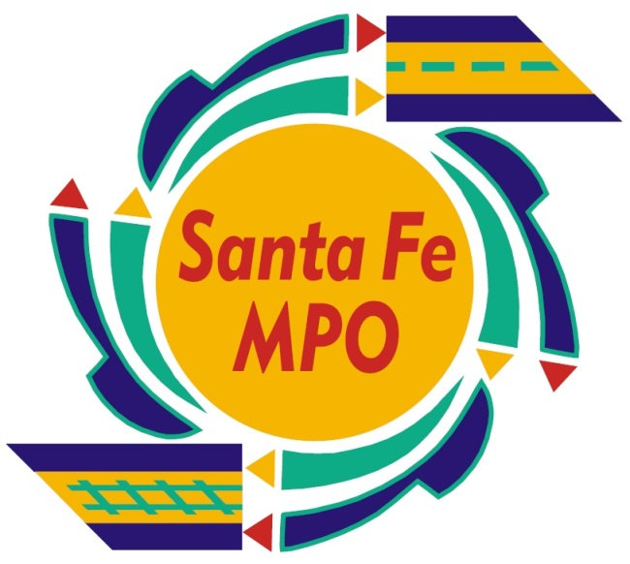
Santa Fe MPO TIP Amendment Form
This form assists MPO agencies in submitting an amendment or requesting an administrative modification to a project in the Transportation Improvement Program (TIP).

For detailed explanations of both formal and administrative TIP amendment procedures please go to:

http://dot.state.nm.us/content/dam/nmdot/STIP/Approved_STIP-TIP_Procedures.pdf

FFY 2020 – 2025 Transportation Improvement Program Change Request Form

Date:
Entity:
Contact Name & Email:
Amendment #:
(FFY/Quarter)
Control #:

Amendment Type (Administrative/Formal) | Explanation

Item Being Changed (Funding Type, Scope, Work  Type, etc.) | Federal Fiscal Year (If Applicable) | Current Budgeted (If Applicable) | Current Local/State Match (If Applicable) | Revised Amount (If Applicable) | Revised Local/State Match (If Applicable) | Brief Description of Change

Review Committee | Date Approved
Technical Committee
Policy Committee
Contact: Leah Yngve, MPOTransportation Planner 505-955-6614 or lxyngve@santafenm.gov

