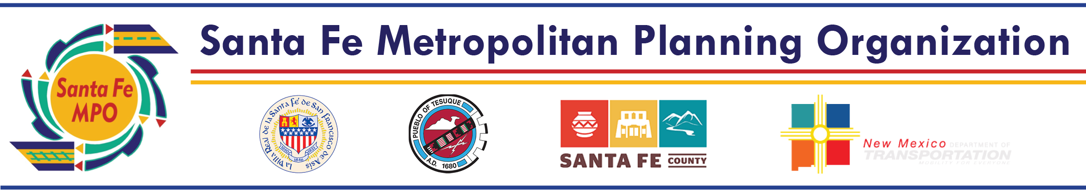

Santa Fe MPO Staff Report

Technical Coordinating Committee: April 25, 2022

Matter of Approval: Prioritization of the SFMPO Transportation Project Fund applications.

Background:
The NMDOT is soliciting applications from local and tribal governments for the FY23 Transportation Project Fund (TPF). The application process is conducted via MPOs and RTPOs. Eligible projects are in the following categories: (1) environmental and other studies; (2) planning; (3) design; (4) construction; and (5) acquisition of rights of way.

The SFMPO is utilizing the following application timeline:
Agencies submit TPF PFFs to the SFMPO 4/01/22
Meeting with NMDOT D5 4/18/22
TCC approves project rankings 4/25/22
Agencies submit final applications to the SFMPO 5/23/22
SFMPO submits all applications to the NMDOT 5/31/22

The received TPF applications are:
MTP Rank | Agency | Project Name | Amount Requested
24 | City of Santa Fe | Sandoval/Montezuma Intersection Improvements: Pedestrian improvements, striping, signage | $950,000
36 | City of Santa Fe | Governor Miles Road Reconstruction: Reconstruct roadway from Richards Avenue to Pueblos del sol and add bike lanes, curb and gutter, sidewalk | $950,000
NR | Santa Fe County | Los Pinos Road Bridge | $1,900,000
4 | Santa Fe County | S100122 - South/East Connector: ROW acquisition, design, and construction of a new roadway | $4,465,000
NR | City of Santa Fe | Arroyo del los Chamisos Crossing | $1,900,000
41 | Santa Fe County | Avenida Del Sur Extension: Construct a new road and upgrade existing roadway from NM14 to A Van Nu Po | $2,375,000
Total |  |  | $12,540,000

Project prioritization criteria provided by the NMDOT:
- Planning: Is this project identified as a priority on a local or regional planning or
programming document? Is this project consistent with local or regional plans?
- Project readiness: If awarded, will the applicant be able to start spending the money within 3 months from receiving the fully executed project agreement?
- Priority Bridge: Is this project addressing a bridge on the NMDOT’s Local Bridge Priority List for Replacement / Rehabilitation?
- Phasing:
  - Is this project part of a phased project previously funded with other state funds (e.g. Local Government Road Fund, Municipal Arterial Program, Capital Outlay, State Road Fund etc.)?
  - Is this project part of a phased project previously funded with TPF? If so, what year?
- Additional criteria identified by the MPO or RTPO

