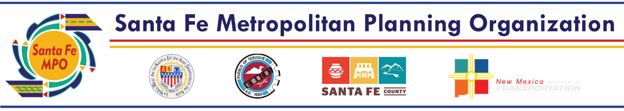

Santa Fe MPO FFY24-29 TIP Change Request Form

This form assists MPO agencies in submitting an amendment or requesting an administrative modification to a project in the Transportation Improvement Program (TIP).

For detailed explanations of both formal and administrative TIP amendment procedures please go to:
https://www.dot.nm.gov/infrastructure/statewide-transportation-improvement-program-stip/

Date:
Entity:
Contact Name & Email:
Amendment #:
(FFY/Quarter)
Control #:

Amendment Type (Administrative/Formal) | Explanation

Item Being Changed (Funding Type, Scope, Work  Type, etc.) | Federal Fiscal Year (If Applicable) | Current Budgeted from a Grant (If Applicable) | Current Local/State Match (If Applicable) | Amount Added from a Grant (If Applicable) | Revised Local/State Match (If Applicable) | Brief Description of Change

Contact: Leah Yngve, MPO Transportation Planner 505-955-6614 or lxyngve@santafenm.gov

